**THEORY:**

**ClickUp** is a comprehensive and highly versatile project management tool designed to help teams and organizations streamline their workflows, track tasks, and enhance collaboration. It is a cloud-based solution that combines task management, project planning, time tracking, and team collaboration in one platform. Known for its flexibility and customizability, ClickUp caters to a wide variety of teams across different industries, from software development and marketing to HR and operations.

**1. The Purpose of ClickUp**

The primary purpose of ClickUp is to centralize and simplify work management by offering a unified platform for task management, team collaboration, project tracking, and reporting. It aims to increase productivity by eliminating the need for multiple tools, providing a single place to manage all aspects of work. ClickUp helps teams stay organized, align on goals, and ensure that projects are completed on time. Unlike some project management tools that focus solely on task tracking, ClickUp offers a range of features that go beyond traditional task management, enabling teams to plan, monitor, and report on their work in real time.

**2. Key Features of ClickUp**

ClickUp offers an extensive set of features, each designed to cater to different aspects of project management and work collaboration:

• Task Management: ClickUp’s core functionality revolves around tasks, which are the primary unit of work within the platform. Tasks can be organized into lists, which are grouped into projects or spaces. Each task can contain detailed descriptions, priorities, due dates, assignees, attachments, comments, checklists, and time tracking.

• Customizable Views: ClickUp offers several views to display tasks in ways that best suit team preferences. These include:

o List View: A simple, linear task list, ideal for traditional project management.

o Board View: A Kanban-style board that lets users drag and drop tasks between columns (e.g., To Do, In Progress, Done).

o Gantt Chart View: A visual representation of tasks with timelines, ideal for planning and tracking project progress.

o Calendar View: Displays tasks on a calendar, providing a clear view of deadlines and milestones.

o Table View: A spreadsheet-like layout for managing tasks, ideal for data heavy projects.

• Workflows and Automations: ClickUp enables users to create custom workflows and automate routine tasks. Automations allow teams to save time by automating repetitive actions, such as moving tasks between statuses, assigning tasks to team members, sending notifications, or updating task properties.

• Time Tracking: ClickUp includes built-in time tracking features that help users log the time spent on tasks. It also integrates with time-tracking tools like Harvest and Toggl. This is helpful for teams that need to report on billable hours, track project timelines, or improve time management.

• Task Dependencies: Tasks can be linked to indicate dependencies, which helps teams visualize task relationships and ensure that work is completed in the correct order. This feature is particularly useful for large projects with complex timelines.

• Goals and OKRs: ClickUp helps teams track goals and OKRs (Objectives and Key Results) by linking tasks and projects to larger business goals. This feature ensures that day-to-day tasks are aligned with broader strategic objectives.

• Docs and Wiki: ClickUp allows users to create and share documents directly within the platform. These docs can be used for notes, knowledge bases, meeting agendas, or project documentation, making it easy to centralize all project-related content.

• Integrations: ClickUp integrates with a wide variety of third-party tools, including Slack, Google Drive, Microsoft Teams, Zoom, GitHub, and many more. This allows teams to centralize communication and workflows within ClickUp, reducing the need to switch between multiple apps.

• Reporting and Analytics: ClickUp provides powerful reporting tools to track project progress, team performance, and productivity. Users can generate detailed reports on time spent, task completion rates, and more. Custom dashboards can be created to visualize key metrics and KPIs.

• Collaboration Tools: ClickUp enhances team collaboration by offering features like comments, mentions, and task sharing. Teams can discuss tasks, share updates, and keep stakeholders in the loop without leaving the platform.

• Custom Fields and Templates: ClickUp offers extensive customization options, such as custom fields that allow users to add specific data points (e.g., priority level, project phase, custom tags) to tasks. Additionally, ClickUp provides templates for tasks, projects, and workflows, helping teams get started quickly and standardize processes.

**3. ClickUp for Different Teams and Use Cases**

ClickUp is designed to be flexible enough to accommodate a variety of teams and workflows. Here are some common use cases:

• Project Management: Project managers use ClickUp to organize tasks, track deadlines, manage resources, and ensure project delivery. The ability to customize workflows, track time, and generate reports makes ClickUp a powerful tool for managing both small and large projects.

• Software Development: Developers use ClickUp for Agile development, tracking user stories, sprints, and bugs. ClickUp's support for different views (e.g., Board, Gantt) and its integration with code repositories (e.g., GitHub) makes it suitable for software teams looking to streamline their development processes.

• Marketing: Marketing teams can use ClickUp to plan and track campaigns, manage content production, and collaborate on creative assets. The Calendar and Gantt chart views allow marketing teams to schedule and visualize their campaigns and ensure that tasks are completed on time.

• Operations and HR: ClickUp is useful for managing day-to-day operations, such as tracking employee onboarding, managing recruitment, and organizing team meetings. It helps HR departments create clear workflows for managing tasks like performance reviews, payroll processing, and employee development.

• Sales Teams: Sales teams can use ClickUp to track leads, manage sales pipelines, and organize customer outreach. ClickUp’s customizable views, task dependencies, and automations help sales teams stay organized and focused on converting leads into customers.

**4. Benefits of Using ClickUp**

• Centralized Platform: ClickUp offers an all-in-one solution that brings together task management, project planning, time tracking, and communication. This reduces the need for multiple tools, streamlining workflows and increasing productivity.

• Flexibility and Customization: ClickUp is highly customizable, allowing users to tailor the platform to meet their unique needs. Whether it’s creating custom workflows, adding fields to tasks, or setting up personal dashboards, ClickUp can adapt to a variety of work styles and industries.

• Collaboration and Communication: With features like task comments, mentions, and document sharing, ClickUp enhances collaboration among team members and stakeholders. This promotes transparency and ensures that everyone is aligned and informed about the progress of tasks and projects.

• Increased Productivity: ClickUp’s task management tools, customizable workflows, and automation features help teams stay organized and focused on their priorities. The ability to track time and set goals ensures that teams can effectively manage their workloads and meet deadlines.

• Scalability: ClickUp is suitable for both small teams and large organizations. Whether you're a freelancer or part of an enterprise team, ClickUp can scale to accommodate your needs, offering a wide range of features that support growth.

5. Common Use Cases for ClickUp

• Task and Project Management: Organizing and tracking tasks, setting deadlines, assigning team members, and ensuring work is completed on time.

• Agile and Scrum Development: Using different views like Board and Gantt charts to plan sprints, track progress, and manage dependencies.

• Content Creation and Marketing: Organizing campaigns, managing deadlines, and collaborating on creative work.

• Team Collaboration: Centralizing communications through comments, notifications, and document sharing to keep everyone aligned and informed.

• Performance Tracking: Setting goals, tracking OKRs, and analyzing team and project performance through reports and dashboards.

**IMPLEMENTATION:**

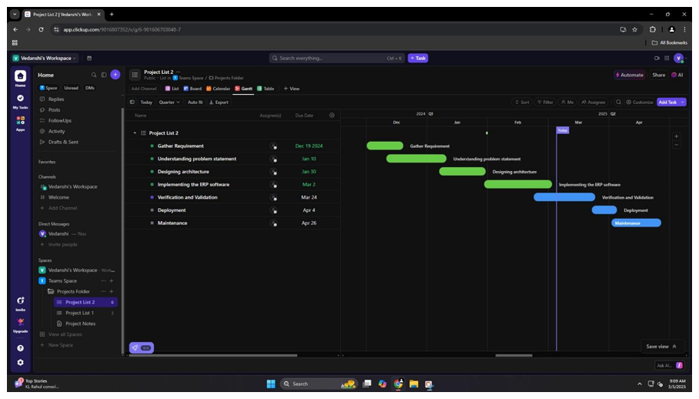

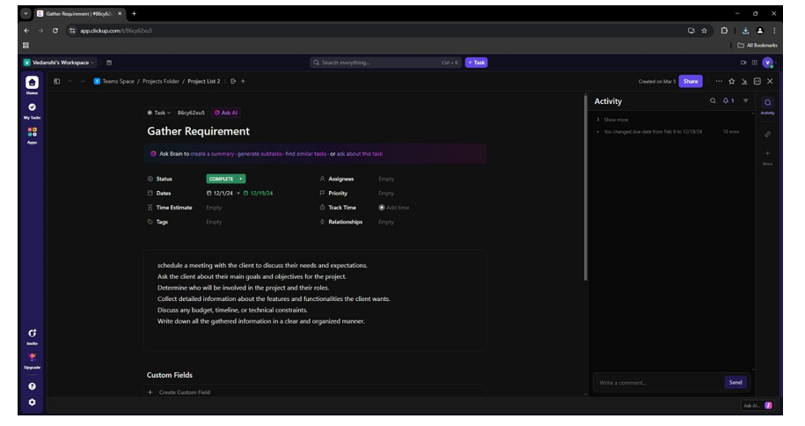

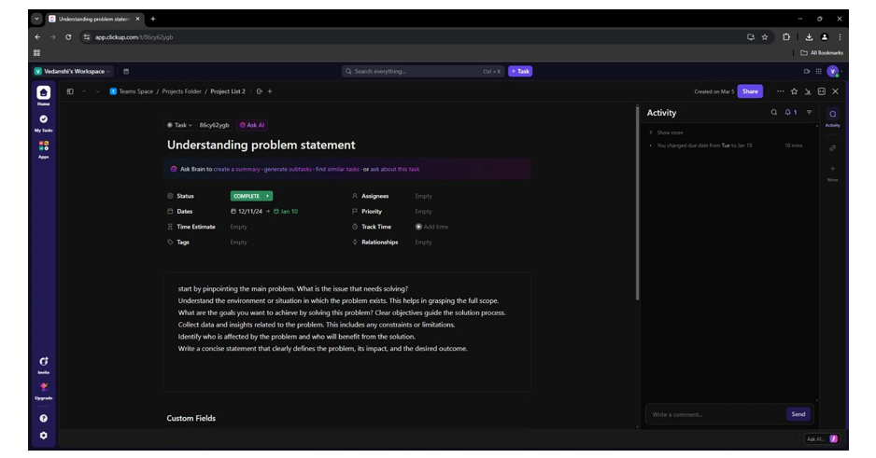

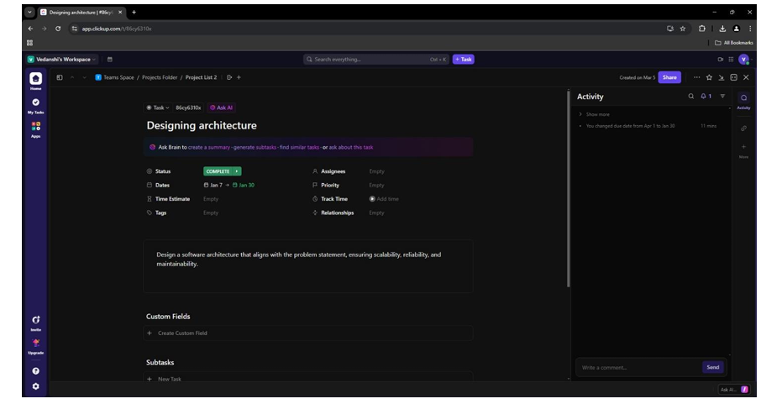

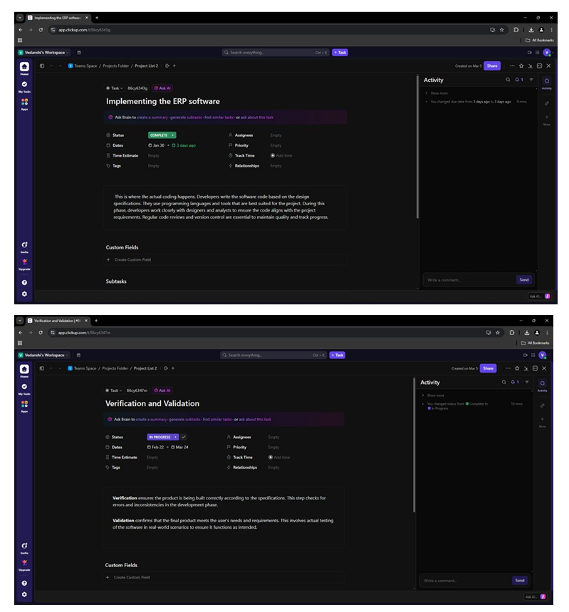

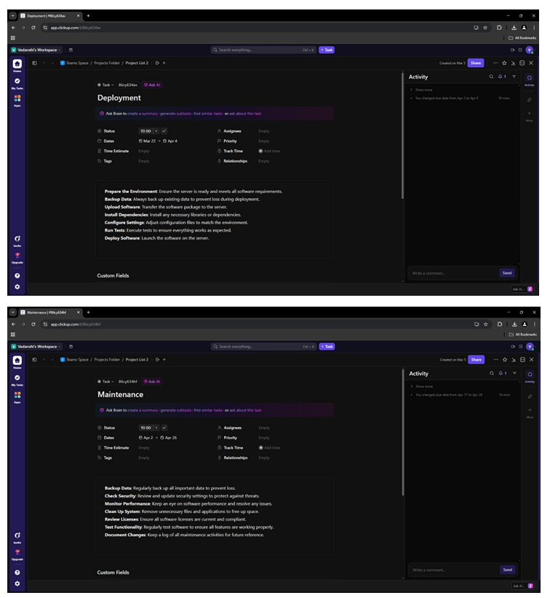

**CONCLUSION:** Thus, we have successfully studied and implemented Project Scheduling using Gantt Chart in ClickUp.